What sequence of Arena modules would you use to generate customer arrivals, use a server, and then have customers leave the system after they’re done with the server?

Create-Process-Dispose

Arena uses the P-I “world view”.

 We can use the Assign Module to change an entity’s picture.

Attributes are properties for individual customers; variables are properties of the entire system.

The system’s work-in-process will typically be a variable – not an attribute.

Batch (combine), separate (permanent – same, temporary – split before disposal), record

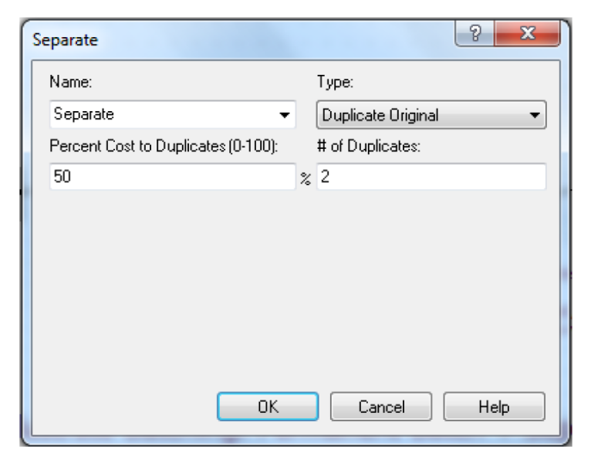

b. A customer enters the block and then emerges along with two exact clones of himself

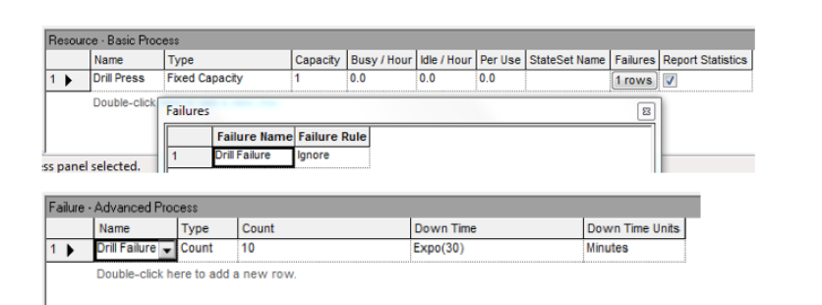

 The resource Drill Press will fail after 10 customers use it, and will remain down for Expo(30) minutes.

where would you find the Expression spreadsheet? - advanced process panel

1. What is the name of the Arena module that can be used to split one customer into two or more clones? Separate or clone

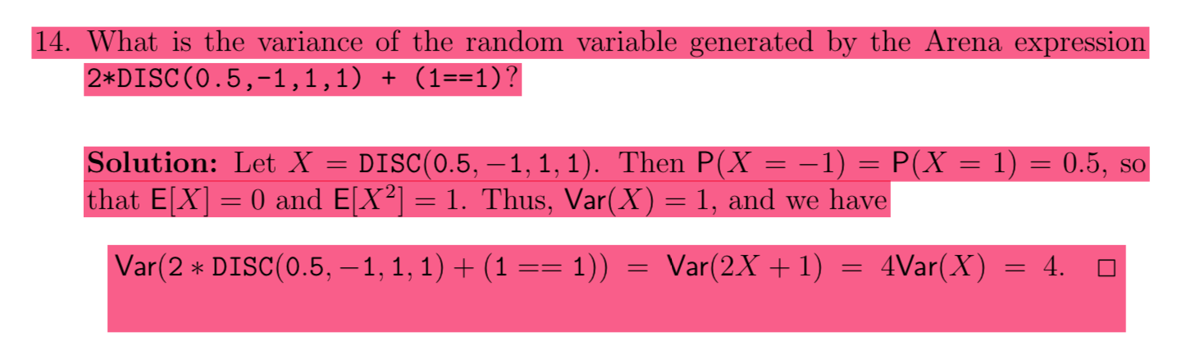

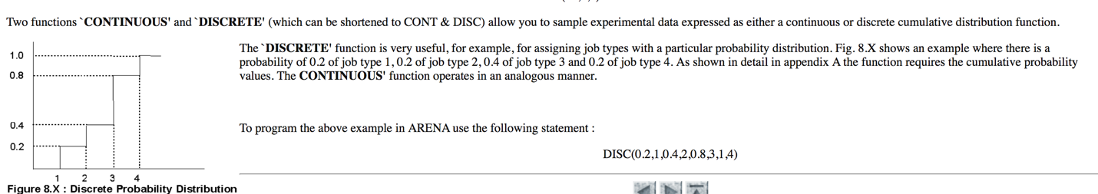

1. where do we specify the maximum buffer size for a certain queue? – in queue block found in the blocks template

NORM(a,b) has variance b^2 = VAR(Norm(0,4)) = 16

Tria(0,1,2) is sum of two Unif(0,1)

False - You can use NORM random variables to generate negative interarrival times.